“3rd edition of N.J. Yasaswy Memorial National Moot Court Competition on constitutional law, 2018 Live”

The Day 1 of the 3rd edition of N.J. Yasaswy Memorial National Moot Court Competition ended with some spectacular performance from our very own students, followed by a Dynamic and lively DJ for the entertainment of the participants and the organising committee.
Stay tune for more updates as the semi-finalists are being decided.
Day 2
HOLA! Thank you for your patience. Presenting to you our semi-finalists *drumroll*
- KIIT Law School, Bhubaneswar.
- Chanakya National law University Patna.
- Christ University Bangalore.
- Indore Institute of legal studies
Semi-Finale Round
Court Room No. 1
TC 11 (Appellant) vs. TC 05 (Respondent)
Judges- Mr Awanish Kumar, Mr Avnish Bhatt & Mr. Sourabh Siddharth
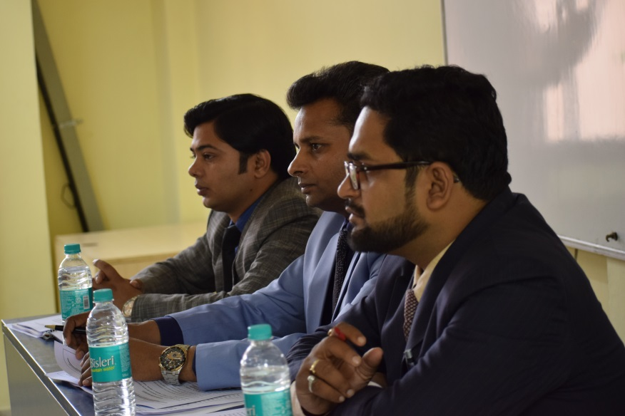
Speaker 1 of the Appellant team approached the dais to state the facts of their issue. The Judges gave a keen ear to the speaker. Furthermore the speaker very tactfully dodged every question thrown at him by the judges. The Judges further questioned article 47 of the constitution in reference to the statements made by the speaker. Keeping in mind the contention raised by the council, the lordships not only raised question regarding the morality of the issue, but also the objectivity relating to the total ban of alcohol.
The respondents were taking note of every questions and answers between the judges and appellant and preparing for their chance to outshine their competitors.
The Respondent’s council started the speech by mentioning the reference cases and putting forth some valid statements in reference to the moot problem. The speaker also managed to rebut the statements of the opponent very skilfully. The Judges raised questions over the evidentiary value of the contention raised by the councils.

Court Room No. 2
TC 19 (Appellant) vs. TC 01 (Respondent)
Judges- Mr S.M. Uzair Iqbal, Dr. Nityanand Singh & Mr Alok Kumar
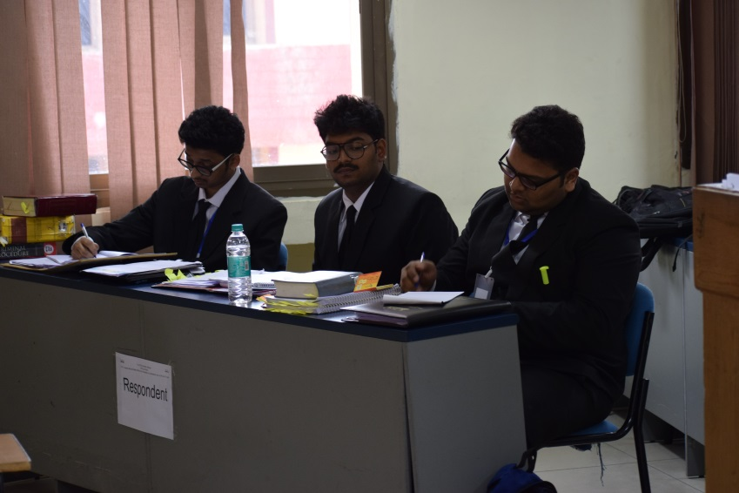
The Speaker 1 approached the dais to state the facts of the issue and to prove them with their research and evidences. The respected lordships were explaining the law and use of participant’s time management. The Judges were triggering the council with questions about the phase manner however; appellant 1 was unable to give a satisfactory answer. The speaker 2 tried to tackle the earlier question by stating the phase policies in 2014, 15 and 17 for the imposition of ban of alcohol. Yet, the judges did not look pleased. The council was warned to make statements for which they have some evidence.
1:45- After a solemn and challenging bout of the competition all the participants were dispersed for lunch in order to cool off and socialise.

Finale
NAMASTEEE! After a mouth-watering lunch here we are at the Auditorium. With a buzz of
Stress and enthusiasm here we are awaiting for the Finale of the 3rd edition of N.J. Yasaswy
Memorial National Moot Court Competition to begin. Hold your breath for some spicy updates.
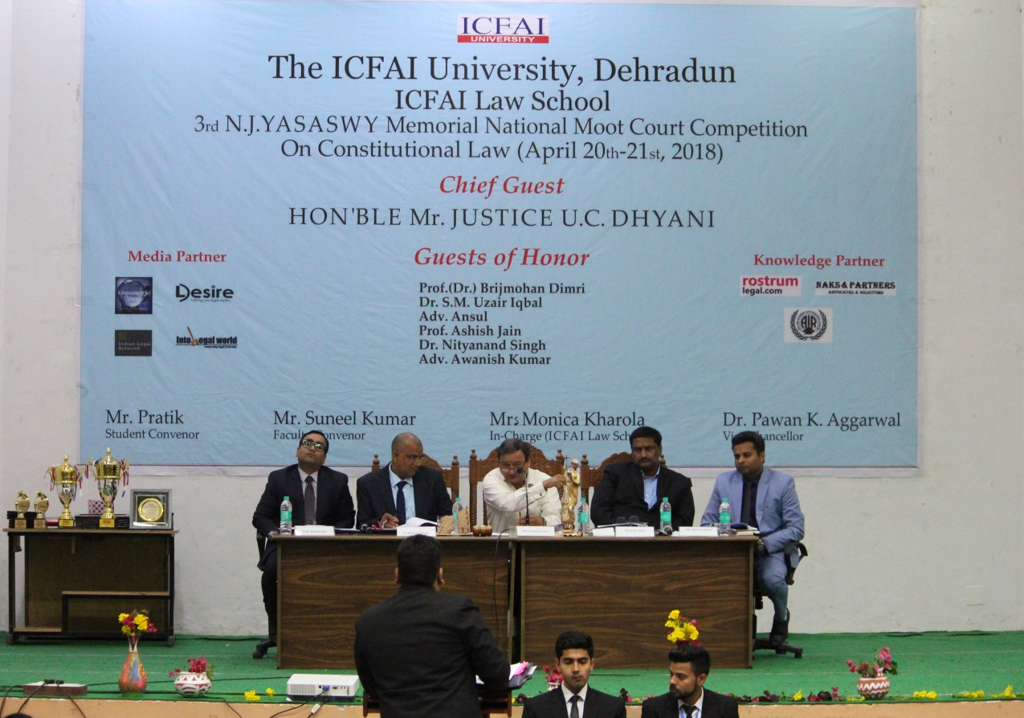
4:10- The judges and both the teams have now arrived at the auditorium for their final showdown. The judges are going through the memorials from both the teams.
The finale was judged by guests of honour-
- Prof. (Dr.) Brijmohan Dimri
- Adv. Ansul
- Prof. Ashish Jain
- Dr. Nityanand Singh
- Adv. Awanish Kumar
Speaker 1 of the appellant team approached the bench to start his speech. The judges were analysing every detail as stated by the speaker. The speaker very skilfully tries to answer every question raised by the judges. The lordships questioned the validity of Article 136 in reference to the issue stated by the council. The speaker with utmost confidence tackled a question concerning the authenticity of the license. There was a little disturbance relating to the memorial of the appellant. Judges seemed a little confused due to the unclear statements made by the council. The opposition team, on the other hand, were giving emphasis to every key word and taking a note. The speaker was asked to summarize his speech in the end.
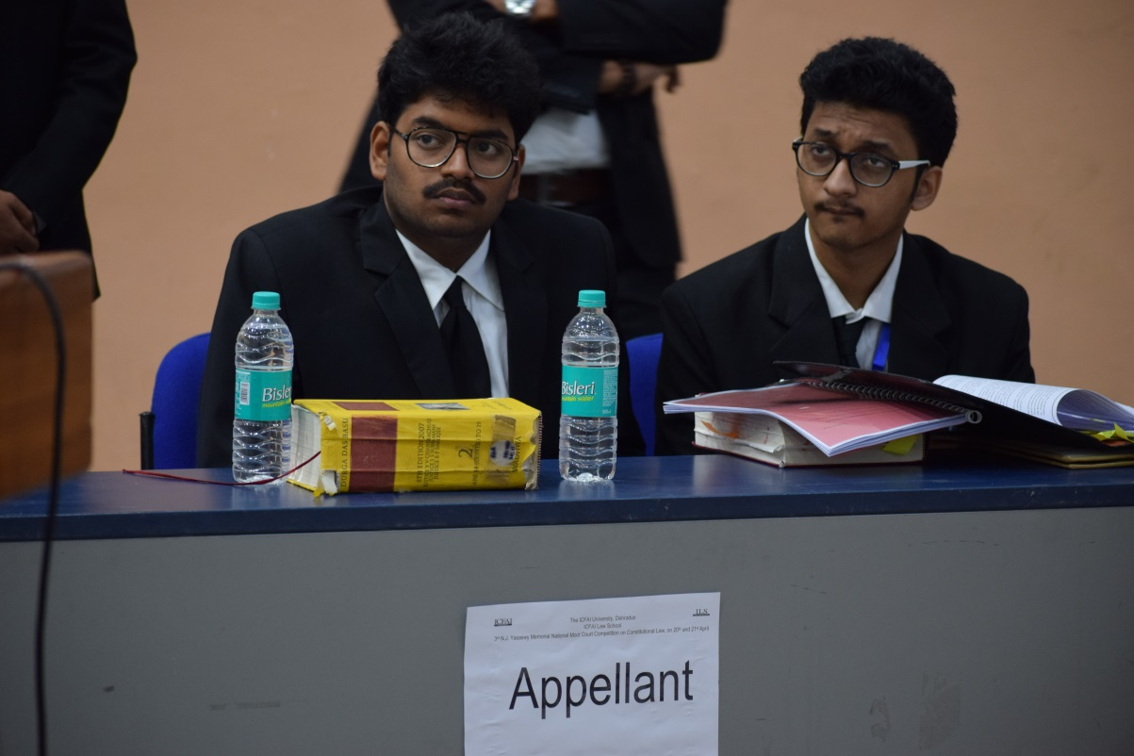
The respondent’s speaker 1 politely and assertively answered the questions and the lordships were putting forth hypothetical situations for testing the understanding and reasonability of the speaker. The speaker managed to respond to such situations with ease.
The speaker pointed out the Manati state and the type of ban and compare it to the ban of alcohol in Gujarat. The speaker clearly takes a stand for the manufacturers of alcohol, their rights and earnings. The judges gave the speaker a min to give a brief of his entire speech.

At the end of the event, we present to you the Winner- Chanakya National law University Patna, of the 3rd edition of N.J. Yasaswy Memorial National Moot Court Competition.
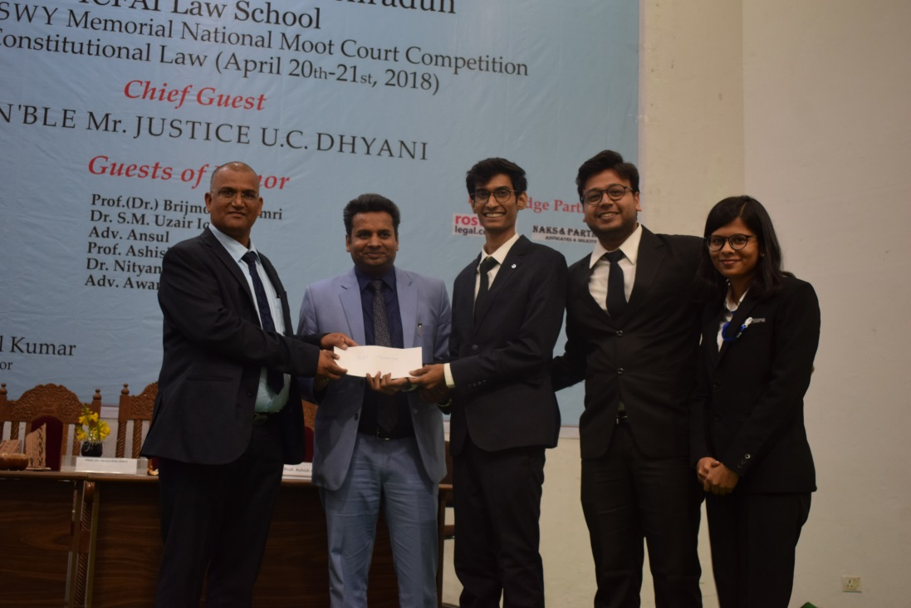
Runner up- KIIT Law School, Bhubaneswar.
Best mooter- Harshit Aryan (Chanakya National law University Patna)
Best memorial- Chanakya National law University Patna
Best Researcher- Shiksha Shrivastava (Chanakya National law University Patna)
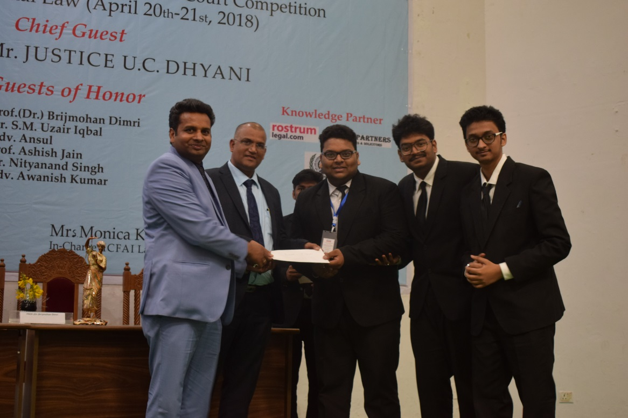
Legal Desire, our media partner, also facilitated the winners of the moot court competition with award money of 10,000 for the winner, 5000 to the runner ups, and 2500 for the best mooter and the best researcher each.
Lastly, the Faculty Co-ordinator along with the Student Co-ordinator acknowledged us with the closing speech. Every other parts of the event were co-ordinated without any hitch under the guiding lights of Mrs. Monica Kharola(Dean of ILS).

Faculty Coordinator Students coordinator
Mr Suneel Kumar Mr Pratik Sharwan

