“ 3rd edition of N.J. Yasaswy Memorial National Moot Court Competition on constitutional law, 2018 Live”
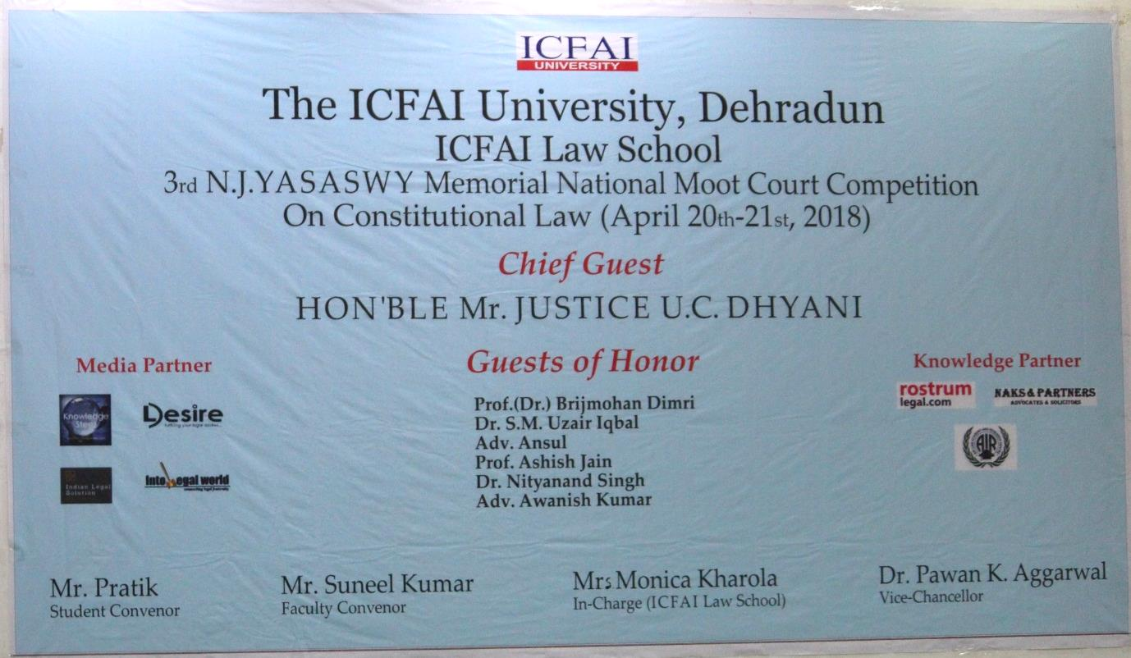
Day 1
Ladies and Gentlemen, we welcome you to the 3rd edition of N.J. Yasaswy Memorial National Moot Court Competition. We, here at ICFAI University, present before you every detail of this competition.
9:34: The teams are arriving at the campus, ready to get themselves registered and start with the competition. The atmosphere is electrifying with students all across India. The Following Teams have participated in the 3rd N.J. Yasaswy Memorial National Moot Court Competition:
- Indore Institute of legal studies
- North Bengal University.
- Faculty of law, Aligarh Muslim University.
- Symbiosis law school Pune.
- Sastra University.
- GLC, Ernakulam
- IMS Unison, Dehradun
- National Law University and judicial academy Assam.
- University of Petroleum and Energy Studies, Dehradun School of Law.
- SVKM’s NMIMS School of Law.
- Institute of Law Kurushetra University.
- KIIT Law School, Bhubaneswar.
- Damodarum Sanjivayya National law university, Vishakhapatnam.
- Chanakya National law University Patna.
- FYLC, University of Rajasthan Jaipur.
- Amity Law School, Noida.
- Himachal Pradesh National Law University, Shimla.
- Faridabad Institute of law.
- Christ University Bangalore.

ICFAI’S welcome committee greeted all the participants and the judges in a traditional manner. Also, gave them warm wishes for their competition.
10:37- The teams are been briefed about the court rooms and rules relating to the competition. Respondent appellants were decided through toss. Later, the memorials were exchanged between the teams. The inauguration ceremony began with the introduction of our chief guests along with the Vide- Chancellor of ICFAI University, Dr. Pawan K. Aggarwal . It took a swing with a motivational speech from Hon’ble Justice U.C. Dhyani.
Lighting of the scared Lamp by Hon’ble Justice U.C. Dhayni, Vice chancellor Dr. Pawan Aggarwal, Mrs. Monica Kharola, along with Mr. Suneel Kumar.
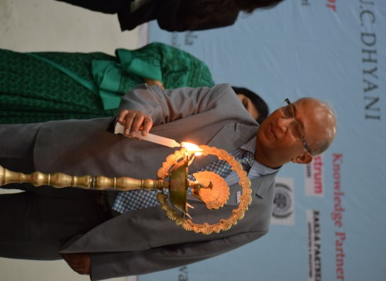

There was a graceful performance of Swarswati Vandana performed by Aditi kulkarni of 2nd year ICFAI University.
11:13 “Let the success make all the noise” the dignitaries were addressed by our very charming faculty of ICFAI University Ms. Ayushi Mittal.
The hon’ble justice approached the dice to shower upon the participants his words of wisdom he Stated that he is the “legislative draftsmen of ICFAI University Act”
He explained the importance of Law in an orderly society like ours, and the legal provisions thereof.
He quoted “You may lose the case but you must not lose the court.”
He further stated that the difference between the Judge and a Lawyer is that of their attitude and also that the image created in the eyes of the judges hold the atmost importance.
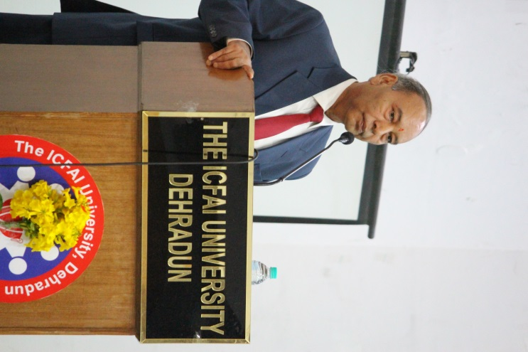
11:49- Our Vice chancellor addressed the chief guest and the guest of honour along with the participants and the students. He encouraged every person part of the event to gain as much knowledge as possible and portrait their best skills
Into legal world, our sponsors, further encouraged the participants by declaring the winning amount i.e. Rs 15,000 for the winner and Rs. 10000 for the runner up. The winner will also get an opportunity to become the face of Into legal world of their respective college along stipend and a certificate. The ace of this deck present in the moot court will get to be the legal reporter amongst other students from all over the world of Into Legal World along with stipend and a certificate.
Mr Suneel Kumar declared the opening of the bench followed by a loud of applause.
Session 1 Started at 12:45 with a lot Enthusiasm.
Court Room No. 1
TC 15 (Appellant) vs. TC 01 (Respondent)
Judges- Mr. Assem paliwal & Ms. Kumari Swati
The speaker 1 from the side of appellant has approached the bench and started off by stating the brief facts of the case. The judges are questioning the authenticity of the authorities being cited by the Speaker, and the response by the speaker doesn’t seem to be to the satisfaction of the judges and they seem unimpressed. Speaker 2 has now approached the dais and is dealing with issue no. 3. Before the Speaker could set the rhythm of the argument, the bench starts with the questions. Speaker is unable to answer the questions of the judges successfully and the confidence of the speaker seems to be wavering. He fares a little better with the 4th issue in what can only come as a relief to the appellants.

Court Room No. 2
TC 07 (Appellant) vs. TC 19 (Respondent)
Judges- Mr. Sarvesh Sahi & Mr. Avishek Raj
The Speaker 1 from the side of the Applicant has approached the podium.
Judges are putting forward questions and asking them to back their authorities with proper citations. The arguments being raised by the Speaker is being contradicted at every point by the judges and this doesn’t seem to be helping the Applicants case at all. They are in a tight position which they might find difficult to maneuverer out of. The tension in the room rises as the Speaker is unable to save their cause. Finally, after repeated signs of time extension, Speaker 2 approaches the dais. The judges are poking holes in the arguments of the Speaker very systematically. The speaker is trying to anchor their drowning boat but it is not proving fruitful. Let’s see what the judges think..

Court Room No. 3
TC 20 (Appellant) vs. TC 04 (Respondent)
Judges- Mr Suneel Kumar & Mrs G. Vinodini Devi
The applicant seeks permission from the judge to approach the bench and begins with his oral arguments; however, the Appellant seems nervous and is fumbling. The judges are getting impatient and ask the Appellant to wrap up their arguments within 10 minutes and then the appellant of the applicant seeks permission to proceed. The judges start to grill the Appellant s on various issues mercilessly and the Appellant is taking various defences but the Judges seem unconvinced.
The respondent after seeking the permission of the judges to approach the bench has started with the issues and the respondent seems very confident and very clear with the issues and judges also seem very impressed and are Intontly hearing the arguments. The judges have now started grilling the appellant on various legal issues. The atmosphere in this courtroom is rather quiet, with a question here and there from the judges and no other drama.
We cannot tell which way this contest will tilt. Stay tuned.

Court Room No. 4
TC 12 (Appellant) vs. TC 02 (Respondent)
Judges- Mrs Samradhi Singh & Dr Akhilesh kumar Pandey
Appellant 1 of the applicants seeks the permission of the Excellencies to proceed.
Appellant 1 has started to explain the finer points of their arguments with assertion. The judges tried to waver the confidence of the appellant however it seems that the appellant was prepared for that as those arrows from the side of excellence were dealt eloquently with by the Appellant . The court is well involved in the orals now, listening Intontly to the arguments being presented by the appellant .
Appellant seems to be well prepared as the question which was asked by the judges was dealt with ease by the Appellant . However, judges are not fully satisfied with the appellant ’s explanation and have now started to grill the Appellant on that particular point.

Court Room No. 5
TC 08 (Appellant) vs. TC 03 (Respondent)
Judges- Mrs. Navtika Singh & Ms. Ruth Vapie
Judges started firing questions at Appellant 1 right away. Some questions were answered to the satisfaction of the judges, some were not. The questions of judges are deceptively clever to confuse the speaker.
Appellant 2 addresses the remaining issues. Judges are relentless with their questions but Appellant 2 is managing the onslaught with vigor. The arguments of Appellant 2 were good and delivered in an articulate manner but he was continuously addressing the judges erroneously.
Appellant 1 from the respondent approaches the bench. She speaks in a composed manner and is making fine points. Now the judge starts asking questions of all sorts. The speaker is trying her best to answer these questions in a manner that the curiosity of the judges be satiated. In the final minutes she submits her issues and their justification.

Court Room No. 6
TC 06 (Appellant) vs. TC 09 (Respondent)
Judges- Mr Saurabh Siddhartha & Ms Anita
The judges have asked the applicants to present the facts. As soon as Appellant 1 started with the legal arguments the judges bombarded them with a lot of questions. The applicants have not filed a compendium which is creating a problem in proving the authorities they have cited. The judges don’t seem satisfied with the arguments and have asked the Appellant to conclude her arguments. The Appellant 2 is unresponsive to the questions asked by the judges.
The respondent appellant has directly started with the legal arguments. The appellant has not been able to provide any authority for some of their arguments and instead have referred to Dictionaries. The Excellencies are not at all convinced with the authorities they have cited.

Court Room No. 7
TC 17 (Appellant) vs. TC 10 (Respondent)
Judges- Ms Ayushi Mittal & Mrs Monica Kharola
We have started with the matchup. 1st Appellant from the side of the appellant has approached the dais. As soon as she cited the relevant authorities for her arguments the Judges began with their questions.
Judges are grilling the 1st Appellant mercilessly but to the Appellant ’s credit, she has managed to keep her cool and answered to the satisfaction of the judges.
As soon as Appellant 2 approaches the dais, the judges start questioning him on the procedural legality of the grounds and principals on which their arguments are based. The appellant s looks confident and the judges seem impressed
Judges are now on a spree of cross-questioning; the Appellant is now wavering in his demeanour and seems to be caught in the web of questions.
Court Room 8
TC 16 (Appellant) vs. TC 11 (Respondent)
Judges- Mr. Avnesh Bhatt & Mr. Prashant Gupta
The Appellant 1 of the applicant has begun in a systematic manner. The excellencies have started with a lot of questions. There has been continuous passing of the chits and Appellant 1 is seeking help from them to answer the excellencies. The excellencies don’t seem convinced with the answers. Appellant 1 continued with his arguments. One of the excellencies just said that he is bored with the arguments. Appellant 2 is pretty confident and starts out and ends confidently.
Appellant 1 for the Respondent has begun on a very confident note and is in total control of the proceedings. Appellant 1 is well versed with the facts and the arguments. The excellencies didn’t get a chance to question the Appellant 1 at any point.
But the tables have turned as soon as Appellant 2 starts with his arguments. He is being bombarded with a lot of questions. The excellencies are discussing a lot amongst themselves. Appellant 2 is facing the brunt of the attack and let’s see if they crumble under the pressure. This is quite an Intoresting contest.

Court Room 9
TC 18 (Appellant) vs. TC 13 (Respondent)
Judges- Mr. Hemant & Mr. Prashant Chauhan
It seems that the judges were prepared to grill the applicants from the word go. Though the applicant is soft- spoken but he confidently answered the questions asked by the judges substantiating with some cases. However, the co-appellant of the applicant seems to be nervous and the judges have taken advantage of this fact and are now bombarding the appellant with questions. The co-appellant seems to be lacking preparation and is unable to answer the questions of the judges and does not seem to be well-versed with the facts. The arguments seems to be slowly getting away from the hands of the applicant as Judges continue to grill them mercilessly.
The judges seem to grill the respondent from the very start just as they did the applicant. The respondent seems to struggle with the questions asked by the Excellencies. However, the co-appellant seems to be confident with the arguments and is fairly answering the questions but the real struggle is to satisfy the Excellencies. The grilling has continued till the end, be it the respondent or the applicant.

Moot Court Hall
TC 14 (Appellant) vs. TC 05 (Respondent)
Judges- Mr. Alok Kumar & Mr Rupaksh
The Appellant for the Applicant side starts with briefing the facts and deals with the issues ably leaving no room for doubt. The judges, however, seem to find certain loopholes in her arguments and are now firing questions at her, which she manages to handle deftly for the moment. Appellant 1 continues with her argument but is again under pressure of the Judges’ questions which she tries to answer to the best of her ability.
Appellant 2 has now taken the floor and continues with their contentions. The Bench has turned quite inquisitive and the Applicant side appears tense. The Respondent side seem to be taking notes at the speed of light to rebut the Applicant’s arguments.
Faculty Coordinator Students coordinator
Mr. Suneel Kumar Mr. Pratik Sharwan

